ZD,
REPORT OF JOINT INVESTIGATION VISIT BY NOSDRA, DPR, SPDC, BAYELSA STATE MINISTRY OF ENVIRONMENT AND PEREMABIRI COMMUNITY AT DIEBU CREEK WELL 15T WELL HEAD @ PEREMABIRI IN SOUTHERN IJAW LGA OF BAYELSA STATE.
INTRODUCTION
Acting on your directives on the SPDC request latter sent in dated 2nd September 2015, a Joint Investigation Visit (JIV) was conducted at the Diebu Creek Well 15T Well Head at Peremabiri in Southern Ijaw Local Government Area of Bayelsa State on the 4th of September, 2015 at about 13:39Hrs. The investigation was completed successfully on the same day. This report provides details.
INCIDENT PARTICULARS: 2015_1483075
FACILITY AFFECTED: DIEBU CREEK WELL 15T WELL HEAD @ PEREMABIRI IN SOUTHERN IJAW LGA OF BAYELSA STATE.
DATE OF SPILL: 22/08/2015
DATE OF INSPECTION: 04/09/2015
CAUSE OF SPILL: THIRD PARTY INTERFERENCE (See Fig.1a & b)
QUANTITY OF CRUDE OIL SPILLED: 0.07Barrels (Approximately 0.1 Barrels)
SPILL POINT COORDINATES: N 04^{O} 39’ 43.1’’
E 006^{O} 03’ 55.0”
NATURE OF IMPACT:
INVESTIGATION TEAM:
- Koms Abam NOSDRA
- Kalio S. H. SPDC
- Duruaku V. SPDC
- Chibuike Chibuzo DPR
- TimiTimi Tariwari BAYELSA STATE MINISTRY OF ENVIRONMENT
- Chief Noel Imgbila PEREMABIRI COMMUNITY
- Ime Effiong NIGERIAN POLICE FORCE
OBSERVATIONS:
- The Spill occurred within SPDC Well Head located on water (See Fig. 4a & b)
- It was a clear case of Third Party Interference (Sabotage). The Cameron Control Unit (CCU) was removed or missing and the Sensor Lines were cut-off (See Fig. 1a & b). The Well Head to the Assembly was completely removed and taken away.
- Oil stain was observed on base of the Well Head and Oil Sheen around the immediate Environ. (See Fig. 2a & b)
- Crude Oil Bubbles were observed from the cut-off point (Top-Assemblage)(See Figs. 2a)
- It is obvious that the water must have carried away the Crude Oil to the adjourning Vegetation and Swamp (See Figs. 3a & b). Only 0.1 Barrels of Crude around 0.0007Ha was seen during JIV.

ISSUES OF CONCERN - FEED BACK
- If a Cameron Control Unit (CCU) and Sensor Lines could be removed and taken away; then we have a great issue at hand. I believe this sensitive Equipment are manufactured for SPDC use ONLY, who then buys and uses them when they are resold?
- This Incidence occurred simultaneously along the three Well Heads (1S, 13T and 15T) in Peremabiri and most probably, the same time. How can this be?
- The Surveillance put in place also calls for questioning.
RECOMMENDATIONS
- Repair work should be carried out.
- The Surveillance Team and SPDC STAFF in charge of that Facility should be questioned.

CONCLUSION
The JIV was successful. This report is subject to your steer and further directives.
Koms Abam
SES
_____________________________
DATE: 05th September, 2015

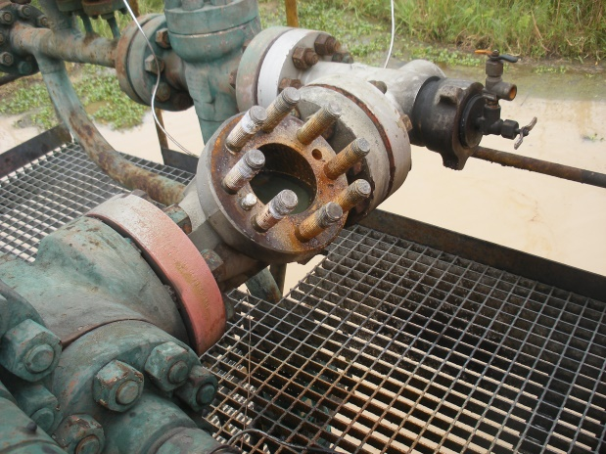 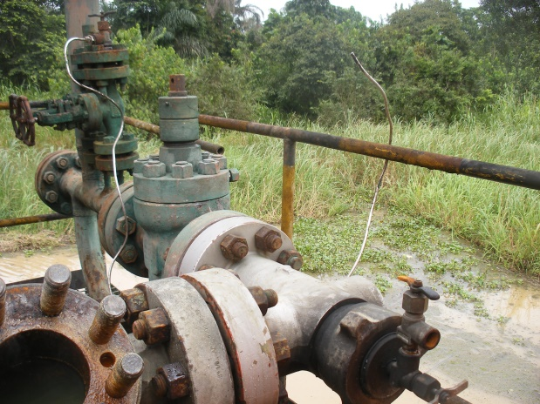 Fig. 1a Cameron Control Unit (CCU) Removed Fig.1b Sensor Lines cut - off
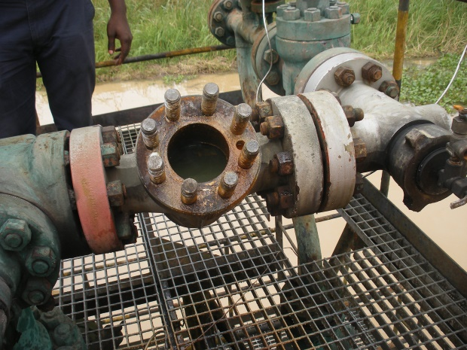 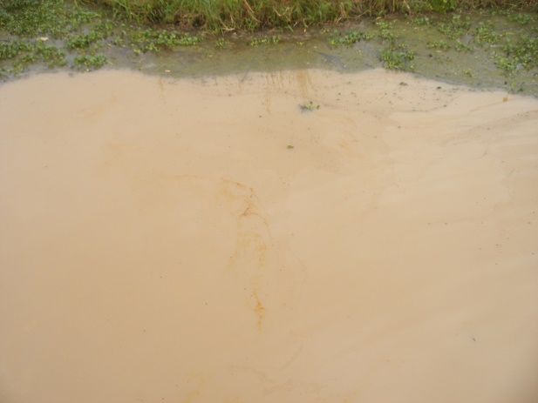 Fig. 2a Oil Stains on the Well Head Base Fig. 2b Oil Sheen around the Environment
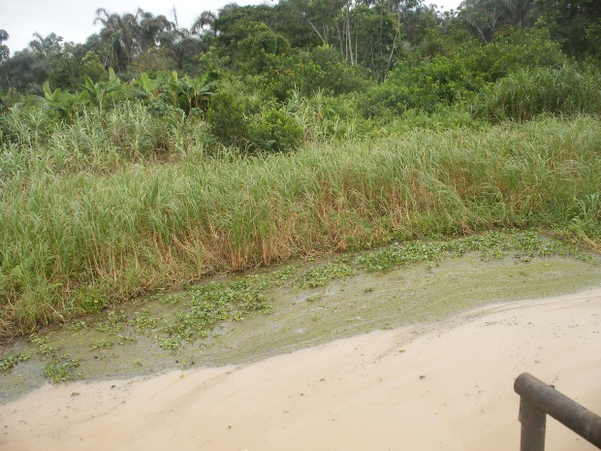 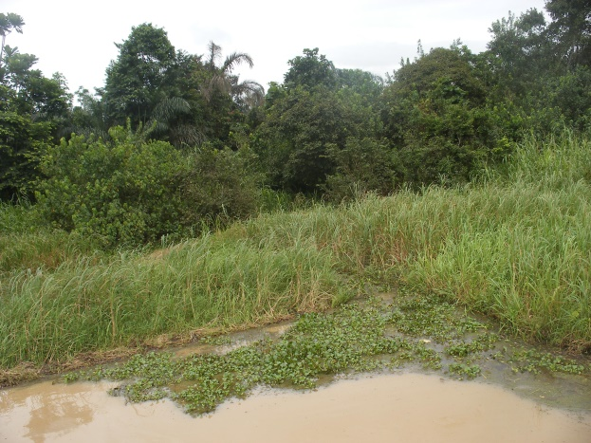 Fig. 3a Vegetation around the Environ. Fig. 3b Adjourning Swamp
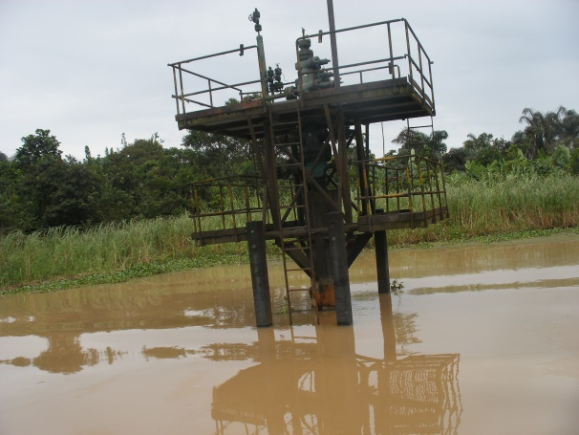 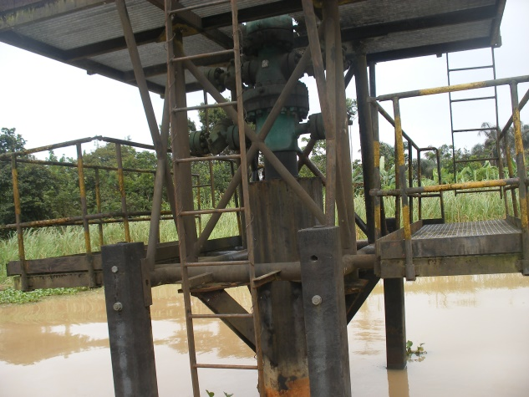 Fig. 4a Well Head 15T Fig. Well Head 15T located on Water.

